New project

Project

Add new item

Left side 🡪 data 🡪 dataset

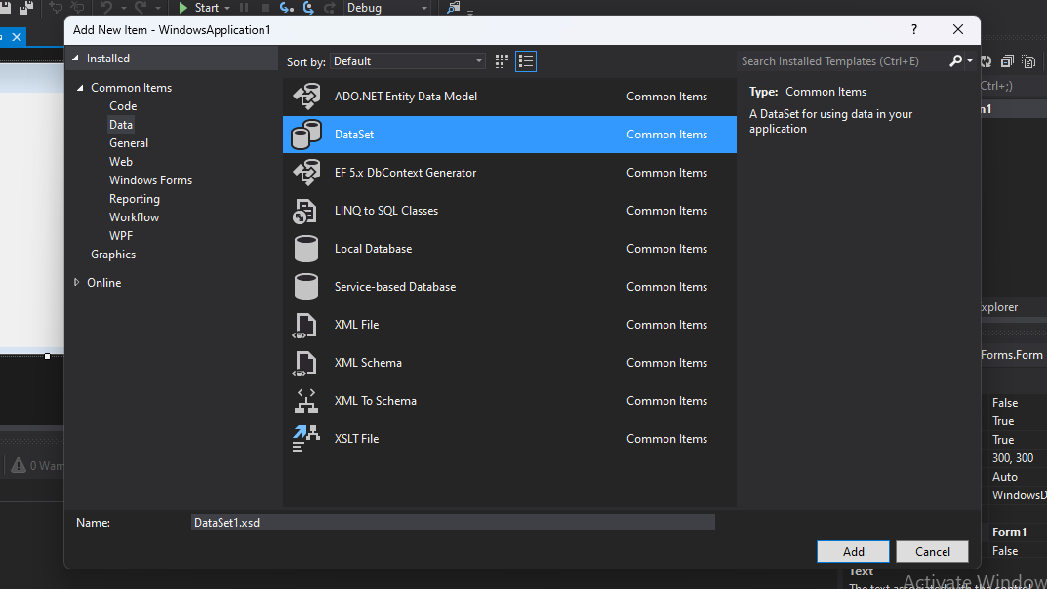

Toolbox 🡪 data table 🡪

Name data table (student)

Right click 🡪 add column (Add columns and all)

Again

Project 🡪 add new item 🡪 reporting(left) 🡪 report 🡪 click add -> new window will open

Toolbox 🡪 list 🡪 new window will open 🡪 data source🡪 new 🡪 select db🡪 set up connection and all🡪 window like this will open

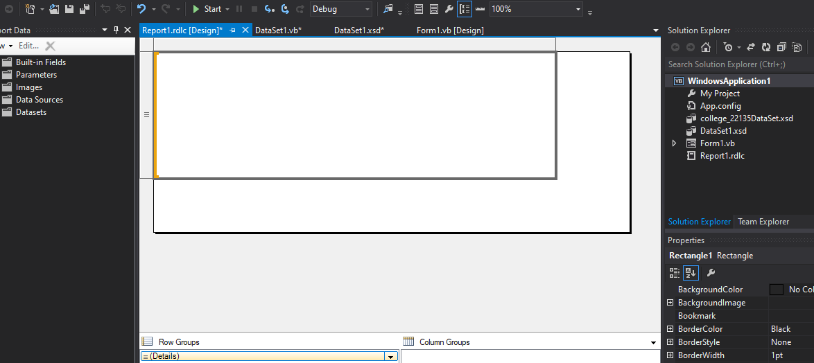

Toolbox🡪 line🡪

If issues inserting datatable columns on list

(toolbox🡪 list🡪 drag things from last folder of report data) and arrange)

In design form 🡪 toolbox🡪 report viewer🡪 top right dropdown🡪 that report ka thingy will show up